**Exercise 2: Implementing the Factory Method Pattern**

**Scenario:**

You are developing a document management system that needs to create different types of documents (e.g., Word, PDF, Excel). Use the Factory Method Pattern to achieve this.

**Steps:**

1. **Create a New Java Project:**
   * Create a new Java project named **FactoryMethodPatternExample**.
2. **Define Document Classes:**
   * Create interfaces or abstract classes for different document types such as **WordDocument**, **PdfDocument**, and **ExcelDocument**.
3. **Create Concrete Document Classes:**
   * Implement concrete classes for each document type that implements or extends the above interfaces or abstract classes.
4. **Implement the Factory Method:**
   * Create an abstract class **DocumentFactory** with a method **createDocument()**.
   * Create concrete factory classes for each document type that extends DocumentFactory and implements the **createDocument()** method.
5. **Test the Factory Method Implementation:**
   * Create a test class to demonstrate the creation of different document types using the factory method.

**IMPLEMENTATION IN ECLIPSE :**

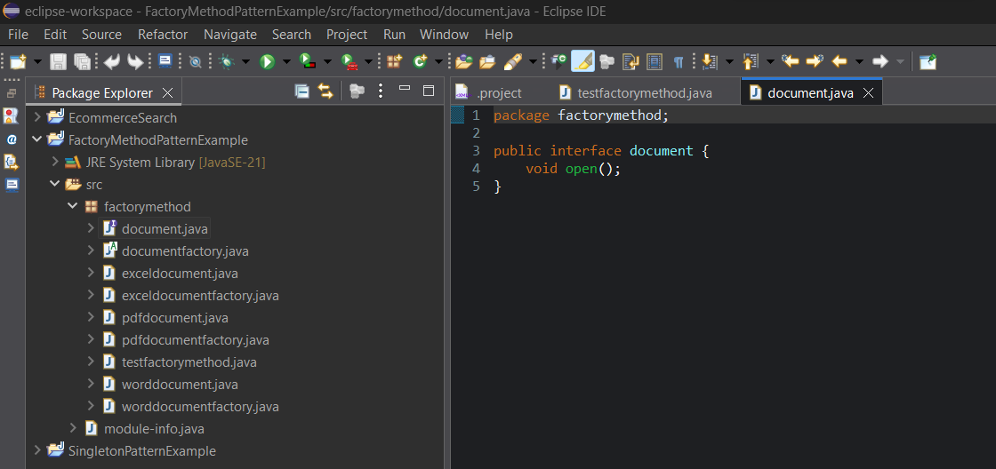

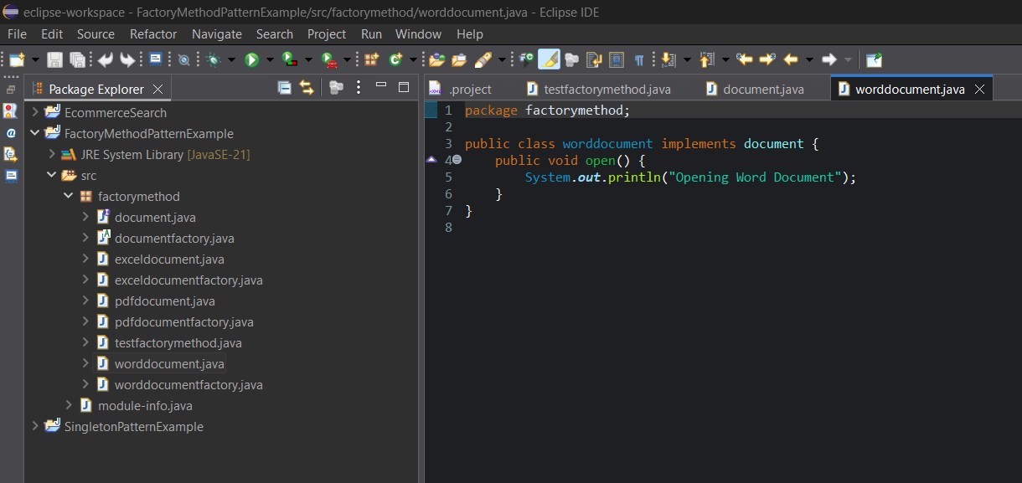

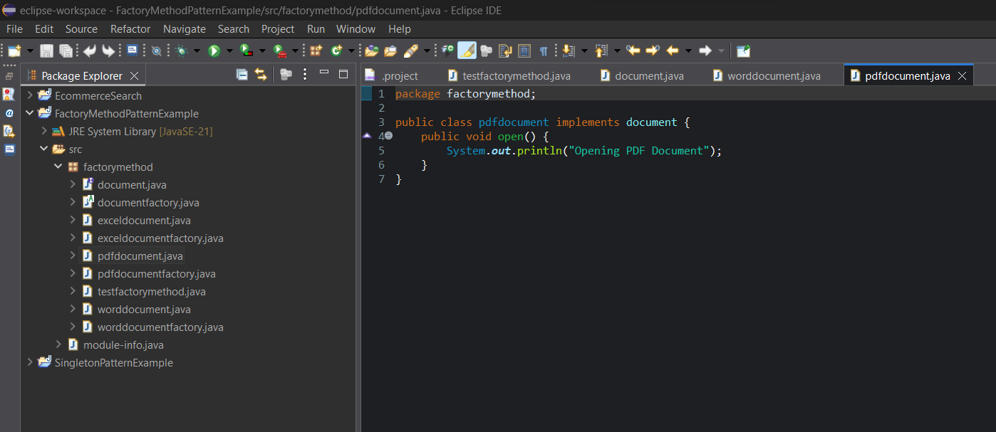

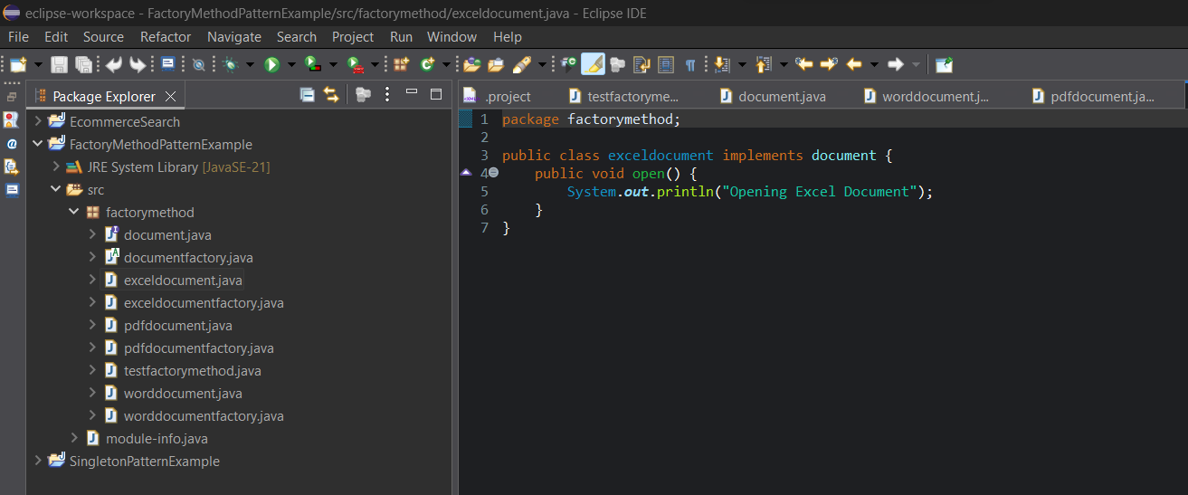

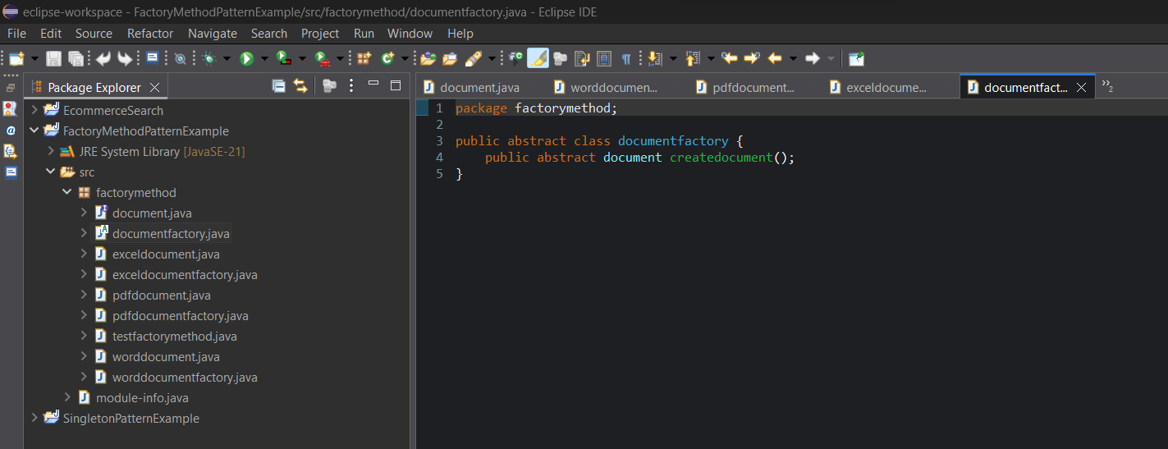

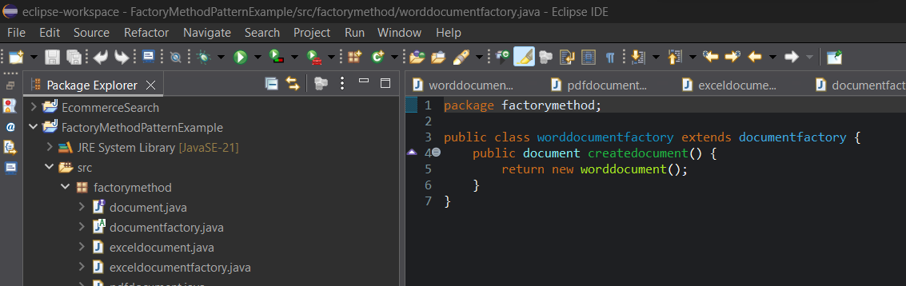

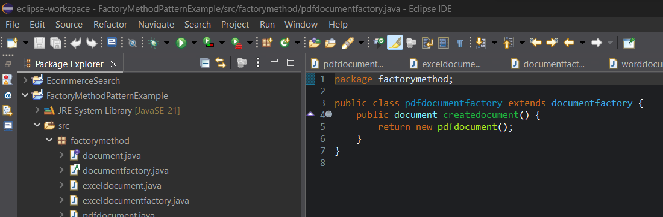

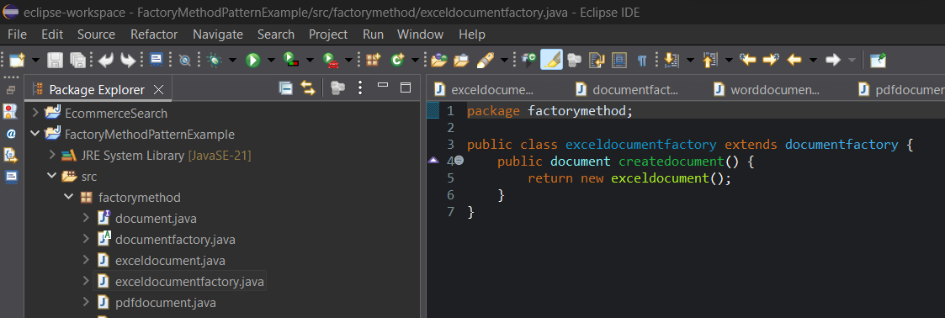

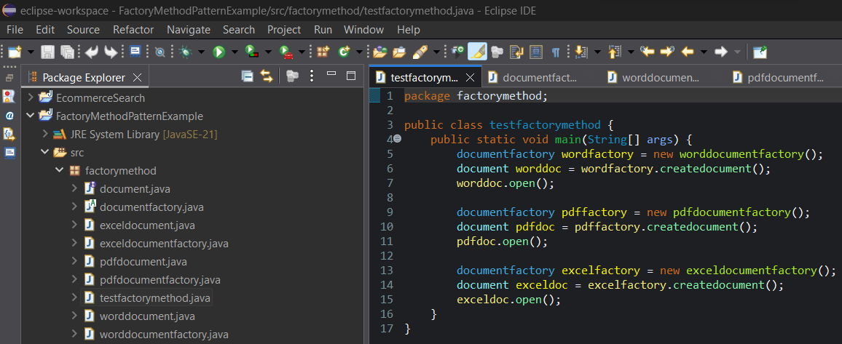

**OUTPUT :**

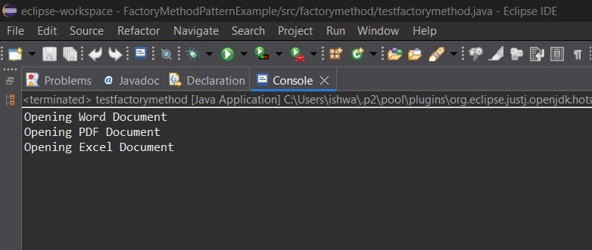

**PROGRAM :**

package factorymethod;

public interface document {

void open();

}

package factorymethod;

public class worddocument implements document {

public void open() {

System.***out***.println("Opening Word Document");

}

}

package factorymethod;

public class pdfdocument implements document {

public void open() {

System.***out***.println("Opening PDF Document");

}

}

package factorymethod;

public class exceldocument implements document {

public void open() {

System.***out***.println("Opening Excel Document");

}

}

package factorymethod;

public abstract class documentfactory {

public abstract document createdocument();

}

package factorymethod;

public class worddocumentfactory extends documentfactory {

public document createdocument() {

return new worddocument();

}

}

package factorymethod;

public class pdfdocumentfactory extends documentfactory {

public document createdocument() {

return new pdfdocument();

}

}

package factorymethod;

public class exceldocumentfactory extends documentfactory {

public document createdocument() {

return new exceldocument();

}

}

package factorymethod;

public class testfactorymethod {

public static void main(String[] args) {

documentfactory wordfactory = new worddocumentfactory();

document worddoc = wordfactory.createdocument();

worddoc.open();

documentfactory pdffactory = new pdfdocumentfactory();

document pdfdoc = pdffactory.createdocument();

pdfdoc.open();

documentfactory excelfactory = new exceldocumentfactory();

document exceldoc = excelfactory.createdocument();

exceldoc.open();

}

}

**OUTPUT :**

